**Comp soft Technology**

**AN INTERNSHIP REPORT ON**

“Stack overflow for Engineering students”

Bachelor of Engineering In

Computer Science and Engineering

Submitted by: Suraj B Prakash (1DT19CS160)

Sourav Nagesh (1DT19CS156)

Dayananda Sagar

Academy of Technology and Management

**ABOUT THE COMPANY**

We are a digital service provider that aims to provide software, designing and marketing solutions to individuals and businesses, we believe that service and quality is the key to success

We provide all kinds of technological and designing solutions from building software to web designs of any custom demand that you may have. Experience The service like none other!

Some of our services include:

Development – We develop responsive, functional, and super-fast websites. We keep user experience in mind while creating websites. A website should load quickly and should be accessible even on a small view-port and slow internet connection.

Mobile Application – We offer a wide range of professional android, iOS & Hybrid app development services for our global clients, from a start up to a large enterprise

Design – We offer professional Graphic design, Brochure design & Logo design. We are experts in crafting visual content to convey the right message to the customers

Consultancy – We are here to provide you with expert advice on your design and development requirement

Videos – we create a polished professional video that impress the audience

**TABLE OF CONTENTS**

-------------------------------------------------------------------

1. Overview of the project
2. Project details
3. Project contents
4. Tools used
5. Implementation
6. Snapshots
7. Bibliography
8. Team details

-------------------------------------------------------------------

**OVERVIEW OF THE PROJECT**

**Project Name:** Stack overflow of Engineering students

**Team Members:** Suraj B Prakash

Sourav Nagesh

This project is based on Web Development and its applications. The main objective of this project is to learn the implementation of HTML, CSS & JavaScript. The basic webpage of this project is created using HTML & styling of the webpage is done using CSS

The backend is done using Python and Django, where python is used for programming purpose and actions, whereas Django can act as a connection between HTML pages and python programs. Django also acts like a database where user and other information will be stored

**PROJECT DETAILS**

Stack overflow is a web-based application which is designed for engineering students. This application mainly focuses on problems that arises for students and they can share their queries in this website. The solution for their query can be acquired easily through other students or expertise from this website.

Stack overflow is basically a question-and-answer website where solutions for a query can be obtain easily. There will be hundreds of students logged in and there can be hundreds of questions

This application will help students for their exams, project & all kinds of work. This application also enables student to interact with each other & also interact with expertise who have answered the query

**PROJECT CONTENTS**

In this project, 2 operations are performed to accomplish the task for user to go through the application

* Registration and login
* Asking questions

Registration to the application is mandatory as user won’t be able to access the required contents and login is also required after registration to go through the website

Asking questions and getting answers is the basis of this application so user can ask questions once logged in and answers can be received from many users

Also user can write answers to different user’s questions to help the others and also gain knowledge from answering their questions

**TOOLS USED**

The tools and software used to build this application are given below

1. Software requirement

* Visual Studio code 2019
* Google chrome or any other browser
* Windows XP/7/8/10 OS or Mac OS or Linux OS

1. Hardware requirement

* Intel core i3 processor
* 4GB RAM
* Monitor with at least 40Hz refresh rate
* 64GB internal Hard Drive

1. Front-End

* HTML (Hyper-text Markup Language)
* CSS (Cascading Style Sheet)
* JS (JavaScript)

1. Back-End

* Python Programming language
* Django (framework)

**IMPLEMENTATION**

1. Source code (Home.HTML):

{% extends 'base.html' %}

{% block content %}

<style>

    a:hover {

        color: #007200;

    }

</style>

<section class="hero">

    <div class="hero-content">

        <h1 class="hero-title">We <span>

                <3 </span> people who code</h1>

        <p class="hero-paragraph">

            We build products that empower developers and connect them to solutions that enable productivity, growth,

            and discovery.

        </p>

        <div class="hero-option">

            <a href="#" class="btn btn-developers ">For developers</a>

            <a href="#" class="btn btn-businesses" style="background-color:#fcbf49">For businesses</a>

            <a href="{% url 'stackbase:question-lists' %}" class="btn btn-developers" style="margin-left: 5px;">Latest

                Questions</a>

        </div>

    </div>

</section>

<section class="for-developers">

    <div class="container">

        <div class="section-head">

            <h2 class="section-title">For developers, by developers

            </h2>

            <div class="section-line"></div>

            <p class="section-description">Stack Overflow is an <a href="#">open community</a> for anyone that codes. We

                help you get answers to your toughest coding questions, share knowledge with your coworkers in private,

                and find your next dream job.

            </p>

        </div>

        <div class="options">

            <div class="option">

                <div class="option-icon">

                    <img src="https://cdn.sstatic.net/Img/home/public-qa.svg?v=d82acaa7df9f" alt="Public Q & A">

                </div>

                <div class="option-title">

                    Public Q&A

                </div>

                <div class="option-description">

                    Get answers to more than 16.5 million questions and give back by sharing your knowledge with others.

                    <a href="#">Sign up</a> for an account.

                </div>

                <div class="option-button">

                    <a href="#" class="option-link btn btn-dark-blue" style="background-color: #ff9500;">

                        Browse questions

                    </a>

                </div>

            </div>

            <div class="option">

                <div class="option-icon">

                    <img src="https://cdn.sstatic.net/Img/home/private-qa.svg?v=2c1de180b6d7" alt="Private Q & A">

                </div>

                <div class="option-title">

                    Public Q&A

                </div>

                <div class="option-description">

                    Level up with Stack Overflow while you work. Share knowledge privately with your coworkers using our

                    flagship Q&A engine.

                </div>

                <div class="option-button">

                    <a href="#" class="option-link btn btn-orange" style="background-color: #0d3b66;">

                        Try for free

                    </a>

                </div>

            </div>

            <div class="option">

                <div class="option-icon">

                    <img src="https://cdn.sstatic.net/Img/home/jobs.svg?v=931d6c0863ee" alt="Browse jobs

">

                </div>

                <div class="option-title">

                    Public Q&A

                </div>

                <div class="option-description">

                    Find the right job through high quality listings and search for roles based on title, technology

                    stack, salary, location, and more.

                </div>

                <div class="option-button">

                    <a href="#" class="option-link btn btn-dark-blue" style="background-color: #ff9500;">

                        Find a job

                    </a>

                </div>

            </div>

        </div>

    </div>

</section>

<section class="for-businesses">

    <div class="container">

        <div class="section-head">

            <h2 class="section-title">For businesses, by developers</h2>

            <div class="section-line"></div>

            <p class="section-description">Our mission is to help developers write the script of the future. This means

                helping you find and hire skilled developers for your business and providing them the tools they need to

                share knowledge and work effectively.</p>

        </div>

        <div class="options">

            <div class="option">

                <div class="option-icon">

                    <img src="https://cdn.sstatic.net/Img/home/private-questions.svg?v=a4f1cfb08f7e" alt="Private Q&A">

                </div>

                <div class="option-description">

                    Quickly find and share internal knowledge with <a href="#" class="option-link">Private Q&A</a>

                </div>

            </div>

            <div class="option">

                <div class="option-icon">

                    <img src="https://cdn.sstatic.net/Img/home/find-candidate.svg?v=9099aa106ad3"

                        alt="Talent solutions">

                </div>

                <div class="option-description">

                    Find the perfect candidate for your growing technical team with <a href="#"

                        class="option-link">Talent solutions</a>

                </div>

            </div>

            <div class="option">

                <div class="option-icon">

                    <img src="https://cdn.sstatic.net/Img/home/accelerate.svg?v=9d4c2786ff02"

                        alt=" Advertising platform">

                </div>

                <div class="option-description">

                    Accelerate the discovery of your products or services through our <a href="#"

                        class="option-link">Advertising platform</a>

                </div>

            </div>

        </div>

    </div>

</section>

<section class="teams">

    <div class="container">

        <div class="teams-head">

            <h2 class="teams-title">Unlock siloed knowledge with Stack Overflow for Teams

            </h2>

            <p class="teams-description">Wikis, chat messages, or formal documentation for knowledge management aren’t

                effective. Our question and answer format is a proven approach for accessing the right information in

                less time.

            </p>

            <div class="teams-details">

                <a href="#" class="btn btn-orange" style="background-color: #f95738;">Learn More</a>

            </div>

        </div>

        <div class="teams-plan">

            <div class="card card-basic">

                <div class="card-header">

                    <h2 class="plan-type">Basic</h2>

                    <p class="plan-description">Private knowledge base for teams</p>

                </div>

                <div class="card-body">

                    <div class="plan-price">

                        <div class="price">$6 USD</div>

                        <span class="per">per teammate / month</span>

                    </div>

                    <div class="plan-features">

                        <div class="plan-feature">

                            <i class="far fa-calendar-alt"></i>

                            <span class="plan-text">Free 30 day trial</span>

                        </div>

                        <div class="plan-feature">

                            <i class="fab fa-keycdn"></i>

                            <span class="plan-text">Your own private space hosted on stackoverflow.com</span>

                        </div>

                        <div class="plan-feature">

                            <i class="fas fa-archive"></i>

                            <span class="plan-text">Fully searchable archive</span>

                        </div>

                    </div>

                </div>

                <div class="card-footer">

                    <a href="#" class="btn btn-card">Get started for free</a>

                </div>

            </div>

            <div class="card card-business">

                <div class="card-most-used">

                    <span>MOST USED</span>

                    <i class="fas fa-city"></i>

                </div>

                <div class="card-header">

                    <h2 class="plan-type">Business</h2>

                    <p class="plan-description">Private knowledge base with SSO and premium features</p>

                </div>

                <div class="card-body">

                    <div class="plan-price">

                        <div class="price">$12 USD

                        </div>

                        <span class="per">per teammate / month</span>

                    </div>

                    <div class="plan-features">

                        <div class="plan-feature">

                            <i class="fas fa-key"></i>

                            <span class="plan-text">Single sign-on (SSO) with SAML</span>

                        </div>

                        <div class="plan-feature">

                            <i class="far fa-chart-bar"></i>

                            <span class="plan-text">Reporting and analytics</span>

                        </div>

                        <div class="plan-feature">

                            <i class="fas fa-plus-square"></i>

                            <span class="plan-text">Priority customer support</span>

                        </div>

                        <div class="plan-feature">

                            <i class="fas fa-star"></i>

                            <span class="plan-text">99.5% uptime

                            </span>

                        </div>

                        <div class="plan-feature">

                            <i class="fas fa-plus"></i>

                            <span class="plan-text">All the features of Basic tier</span>

                        </div>

                    </div>

                </div>

                <div class="card-footer">

                    <a href="#" class="btn btn-card">Get started</a>

                </div>

            </div>

            <div class="card card-enterprise">

                <div class="card-header">

                    <h2 class="plan-type">Enterprise</h2>

                    <p class="plan-description">Standalone knowledge base with enhanced security and flexible hosting

                    </p>

                </div>

                <div class="card-body">

                    <div class="plan-price">

                        <div class="price">Custom pricing </div>

                        <span class="per">Let’s talk about what you need</span>

                    </div>

                    <div class="plan-features">

                        <div class="plan-feature">

                            <i class="fas fa-key"></i>

                            <span class="plan-text">Single sign-on with AD or SAML</span>

                        </div>

                        <div class="plan-feature">

                            <i class="fas fa-mountain"></i>

                            <span class="plan-text">Host on your cloud or servers – or our private managed cloud</span>

                        </div>

                        <div class="plan-feature">

                            <i class="fas fa-code"></i>

                            <span class="plan-text">Robust read and write API</span>

                        </div>

                        <div class="plan-feature">

                            <i class="fas fa-user"></i>

                            <span class="plan-text">Your own customer success and community building

                                representative</span>

                        </div>

                        <div class="plan-feature">

                            <i class="fas fa-star"></i>

                            <span class="plan-text">99.5% uptime SLA and priority support</span>

                        </div>

                    </div>

                </div>

                <div class="card-footer">

                    <a href="#" class="btn btn-card">Request a demo</a>

                </div>

            </div>

        </div>

        <div class="teams-footer">

            <a class="teams-footer-item">

                <img src="https://cdn.sstatic.net/Img/product/teams/endorsements/g2.svg?v=670bf9279910" alt="">

                <div class="teams-footer-text"><strong>Leader</strong> <span>Summer 2020</span> </div>

            </a>

            <a class="teams-footer-item">

                <img src="https://cdn.sstatic.net/Img/product/teams/endorsements/g2.svg?v=670bf9279910" alt="">

                <div class="teams-footer-text"><strong>Users Love Us</strong> </div>

            </a>

            <a class="teams-footer-item">

                <img src="https://cdn.sstatic.net/Img/product/teams/endorsements/fastco.svg?v=5ebc802a76c7" alt="">

                <div class="teams-footer-text"><strong>Most Innovative Companies</strong> <span>2019</span> </div>

            </a>

        </div>

    </div>

</section>

<section class="hire">

    <div class="container">

        <div class="hire-content">

            <div class="hire-item">

                <img src="https://cdn.sstatic.net/Img/home/find-candidate.svg?v=9099aa106ad3" alt="" class="hire-icon">

                <h4 class="hire-item-title">Hire your technical talent</h4>

                <p class="hire-item-description">We help expand your technical hiring strategy to promote your employer

                    brand and highlight relevant open roles to our community of over 100 million developers and

                    technologists.</p>

                <a href="#" class="btn btn-orange" style="background-color: #5a189a;">Stack Overflow Talent</a>

            </div>

            <div class="hire-item">

                <img src="https://cdn.sstatic.net/Img/home/accelerate.svg?v=9d4c2786ff02" alt="" class="hire-icon">

                <h4 class="hire-item-title">Reach developers worldwide

                </h4>

                <p class="hire-item-description">Use the world’s largest resource for people who code to help you

                    increase awareness and showcase your product or service across Stack Overflow’s network of Q&A

                    sites. </p>

                <a href="#" class="btn btn-orange" style="background-color: #5a189a;">Stack Overflow Advertising</a>

            </div>

        </div>

    </div>

</section>

<section class="questions">

    <div class="container">

        <div class="questions-content">

            <div class="questions-header">

                <h3 class="question-title">Questions are everywhere, answers are on Stack Overflow</h3>

            </div>

            <div class="questions-body">

                <div class="questions-body-items">

                    <div class="questions-body-item" data-id="0">

                        <img src="https://cdn.sstatic.net/Img/home/ask-a-question.svg?v=f4f2050b0297" alt=""

                            class="question-item-icon">

                        <div class="question-item-text">Ask a question</div>

                        <div class="question-arrow-right"></div>

                    </div>

                    <div class="questions-body-item" data-id="1">

                        <img src="https://cdn.sstatic.net/Img/home/votes.svg?v=748a8f48a8e2" alt=""

                            class="question-item-icon">

                        <div class="question-item-text">Vote on everything</div>

                        <div class="question-arrow-right"></div>

                    </div>

                    <div class="questions-body-item" data-id="2">

                        <img src="https://cdn.sstatic.net/Img/home/answer.svg?v=4cd8048a676c" alt=""

                            class="question-item-icon">

                        <div class="question-item-text">Answer questions</div>

                        <div class="question-arrow-right"></div>

                    </div>

                </div>

                <div class="questions-body-item-content">

                    <img src="https://cdn.sstatic.net/Img/home/illo-feats-vote.svg?v=9d2eb0efdc17" alt=""

                        class="question-item-content-img">

                    <h4 class="question-item-content-text">

                        Accept the answer which solved your problem to let others benefit from the valuable information.

                    </h4>

                    <a href="#" class="btn btn-orange question-item-content-btn">Create an account</a>

                </div>

                <div class="questions-body-items">

                    <div class="questions-body-item" data-id="3">

                        <img src="https://cdn.sstatic.net/Img/home/tags.svg?v=913379eb09eb" alt=""

                            class="question-item-icon">

                        <div class="question-item-text">Tag your question</div>

                        <div class="question-arrow-left"></div>

                    </div>

                    <div class="questions-body-item" data-id="4">

                        <img src="https://cdn.sstatic.net/Img/home/accept.svg?v=27d5be078970" alt=""

                            class="question-item-icon">

                        <div class="question-item-text">Accept a answer</div>

                        <div class="question-arrow-left"></div>

                    </div>

                    <div class="questions-body-item" data-id="5">

                        <img src="https://cdn.sstatic.net/Img/home/get-recognized.svg?v=3b339d9aa10c" alt=""

                            class="question-item-icon">

                        <div class="question-item-text">Get recognized</div>

                        <div class="question-arrow-left"></div>

                    </div>

                </div>

            </div>

            <div class="questions-footer">

                <h3 class="question-title">Learn and grow with Stack Overflow</h3>

                <div class="questions-grid">

                    <div class="questions-grid-item">

                        <div class="grid-item-img">

                            <img src="https://cdn.sstatic.net/Img/home/developer.svg?v=b930de7967a7" alt="">

                        </div>

                        <h4 class="grid-item-title">Write the script of the future</h4>

                        <p class="grid-item-description">Get your coding questions answered to learn, build, and level

                            up whether you’re beginning with

                            <a href="#">JavaScript</a> or a <a href="#">React</a> professional.

                        </p>

                    </div>

                    <div class="questions-grid-item">

                        <div class="grid-item-img">

                            <img src="https://cdn.sstatic.net/Img/home/open-source.svg?v=847b604fd2ab" alt="">

                        </div>

                        <h4 class="grid-item-title">Support open source

                        </h4>

                        <p class="grid-item-description">Reach users of your project by following tags, answering

                            newcomer questions, and empowering experts in the community.

                            <a href="#"> Read the curl project creator’s story.</a>

                        </p>

                    </div>

                    <div class="questions-grid-item">

                        <div class="grid-item-img">

                            <img src="https://cdn.sstatic.net/Img/home/advocate.svg?v=4b03cfb93502" alt="">

                        </div>

                        <h4 class="grid-item-title">Acquire and share knowledge

                        </h4>

                        <p class="grid-item-description">Answer questions and <a href="#">gain insights</a> from an

                            audience of developers using your technology on Stack Overflow.

                        </p>

                    </div>

                    <div class="questions-grid-item">

                        <div class="grid-item-img">

                            <img src="https://cdn.sstatic.net/Img/home/career-switcher.svg?v=a41416ff19df" alt="">

                        </div>

                        <h4 class="grid-item-title">Find career opportunities

                        </h4>

                        <p class="grid-item-description">Create a profile that shows off your expertise and credentials

                            to help you make your next move. Start your

                            <a href="#">Developer Story</a>.

                        </p>

                    </div>

                </div>

            </div>

        </div>

    </div>

</section>

{% endblock content %}

1. Source code (Base.html)
2. {% load static %}
3. <!doctype html>
4. <html lang="en">
5. <head>
6. <meta charset="UTF-8">
7. <meta name="viewport"
8. content="width=device-width, user-scalable=no, initial-scale=1.0, maximum-scale=1.0, minimum-scale=1.0">
9. <meta http-equiv="X-UA-Compatible" content="ie=edge">
10. <title>Stack Overflow - Where Developers Learn, Share, &amp; Build Careers</title>
11. <link rel="shortcut icon" href="https://cdn.sstatic.net/Sites/stackoverflow/Img/favicon.ico?v=ec617d715196">
12. <link rel="apple-touch-icon"
13. href="https://cdn.sstatic.net/Sites/stackoverflow/Img/apple-touch-icon.png?v=c78bd457575a">
14. <link rel="image_src" href="https://cdn.sstatic.net/Sites/stackoverflow/Img/apple-touch-icon.png?v=c78bd457575a">
15. <link rel="stylesheet" href="https://cdnjs.cloudflare.com/ajax/libs/font-awesome/5.14.0/css/all.min.css"
16. integrity="sha512-1PKOgIY59xJ8Co8+NE6FZ+LOAZKjy+KY8iq0G4B3CyeY6wYHN3yt9PW0XpSriVlkMXe40PTKnXrLnZ9+fkDaog=="
17. crossorigin="anonymous" />
18. *<!-- <link rel="stylesheet" href="assets/css/main.css"> -->*
19. <link rel="stylesheet" href="https://maxcdn.bootstrapcdn.com/bootstrap/4.0.0/css/bootstrap.min.css"
20. integrity="sha384-Gn5384xqQ1aoWXA+058RXPxPg6fy4IWvTNh0E263XmFcJlSAwiGgFAW/dAiS6JXm" crossorigin="anonymous">
21. <link rel="stylesheet" href=" {% static 'main.css' %}">
22. <link rel="stylesheet" href=" {% static 'base.css' %} ">
23. *<!-- <link href="https://cdn.jsdelivr.net/npm/bootstrap@5.1.1/dist/css/bootstrap.min.css" rel="stylesheet" integrity="sha384-F3w7mX95PdgyTmZZMECAngseQB83DfGTowi0iMjiWaeVhAn4FJkqJByhZMI3AhiU" crossorigin="anonymous"> -->*
24. </head>
25. <body>
26. <header>
27. <div class="nav-container">
28. <nav>
29. <div class="nav-brand">
30. <div class="hamburger-menu-container">
31. <div class="hamburger-menu">
32. <div class="line"></div>
33. <div class="line"></div>
34. <div class="line"></div>
35. </div>
36. <div class="nav-dropdown-menu">
37. <a href="#" class="current-link">Home</a>
38. <h5>Public</h5>
39. <ul class="nav-ul">
40. <li class="nav-item">
41. <i class="fas fa-globe-europe"></i>
42. <a href="" class="nav-link">Stack Overflow</a>
43. </li>
44. <li class="nav-item"><a href="#" class="nav-link">Tags</a></li>
45. <li class="nav-item"><a href="#" class="nav-link">Users</a></li>
46. </ul>
47. <h5>Find a Job</h5>
48. <ul class="nav-ul">
49. <li class="nav-item"><a href="#" class="nav-link">Jobs</a></li>
50. <li class="nav-item"><a href="#" class="nav-link">Companies</a></li>
51. </ul>
52. <h5>Teams <a href="#">What's this ?</a></h5>
53. <a href="#" class="nav-link">
54. <i class="fas fa-briefcase"></i>
55. <span>Free 30 Day Trial</span>
56. </a>
57. </div>
58. </div>
59. <a href="" class="nav-icon">
60. <i class="fab fa-stack-overflow"></i>
61. <a href="{% url 'stackbase:home' %}" style="text-decoration: none; color: black;">
62. <div class="nav-icon-text">stack <span class="nav-bold-text">overflow</span>
63. </a>
64. *<!-- <div class="nav-icon-text">stack <span class="nav-bold-text">overflow</span> -->*
65. </div>
66. </a>
67. </div>
68. <div class="nav-base-links">
69. <ul>
70. <li><a href="#">About</a></li>
71. <li><a href="#">Products</a></li>
72. <li><a href="#">For Teams</a></li>
73. </ul>
74. </div>
75. <div class="nav-search">
76. <div class="search-container">
77. <i class="fas fa-search"></i>
78. <form action="" method="GET">
79. <input type="text" id="" name="search-area" placeholder="Search...">
80. <button type="submit"
81. style="margin-left: 340px; border-radius: 25px; border: none; padding: 8px;">Search</button>
82. </form>
83. </div>
84. <div class="search-hints">
85. <div class="search-arrow-up"></div>
86. <div class="search-hint-body">
87. <div class="hints-grid-column">
88. <div class="hint-text"><span>[tag] </span> search within a tag</div>
89. <div class="hint-text"><span>user:1234 </span> search by author</div>
90. <div class="hint-text"><span>"words here"</span> exact phrase </div>
91. </div>
92. <div class="hints-grid-column">
93. <div class="hint-text"><span>answers:0</span> unanswered questions</div>
94. <div class="hint-text"><span> score:3 </span> posts with a 3+ score</div>
95. </div>
96. </div>
97. <div class="search-hint-footer">
98. <a href="#" class="btn">Ask a question</a>
99. <a href="#" class="search-help">Search help</a>
100. </div>
101. </div>
102. </div>
103. <div class="nav-right-buttons">
104. <div class="search-btn">
105. <i class="fas fa-search"></i>
106. </div>
107. {% if user.is_authenticated %}
108. <a href="{% url 'login' %}" class="btn btn-login ">Profile</a>
109. <a href="{% url 'logout' %}" class="btn btn-register" style="background-color: #0d3b66;"> Logout</a>
110. {% else %}
111. <a href=" {% url 'login' %}" class="btn btn-login" style="background-color: #bbd0ff;">Log in</a>
112. <a href="{% url 'register' %}" class="btn btn-register" style="background-color: #bbd0ff;">Sign up</a>
113. {% endif %}
114. </div>
115. </nav>
116. </div>
117. *<!-- <h1 style="font-size: 20px;">hello</h1> -->*
118. <div style="margin-top: 10px;">
119. {% if messages %}
120. {% for message in messages %}
121. <div class="alert alert-{{ message.tags }}" role="alert">
122. <h4 style="text-align: center;">{{ message }}</h4>
123. </div>
124. {% endfor %}
125. {% endif %}
126. </div>
127. </header>
128. *<!-- Add block content here -->*
129. *<!-- Add enbdblock content here -->*
130. {% block content %}
131. {% endblock content %}
132. <section class="jobs">
133. <div class="container">
134. <div class="jobs-content">
135. <h3 class="jobs-title">Looking for a job?</h3>
136. <div class="jobs-body">
137. <div class="jobs-items">
138. <div class="column">
139. <div class="jobs-item">
140. <img src="https://cdn.sstatic.net/Img/home/jobs-tech.svg?v=42f011c01763" alt=""
141. class="jobs-item-img">
142. <p class="jobs-item-description">Browse jobs by technology</p>
143. </div>
144. <div class="jobs-item">
145. <img src="https://cdn.sstatic.net/Img/home/jobs-salary.svg?v=401840ff8931" alt=""
146. class="jobs-item-img">
147. <p class="jobs-item-description">Browse jobs by salary</p>
148. </div>
149. </div>
150. <div class="column">
151. <div class="jobs-item">
152. <img src="https://cdn.sstatic.net/Img/home/jobs-visa.svg?v=1f3acc6dc772" alt=""
153. class="jobs-item-img">
154. <p class="jobs-item-description">Browse jobs by visa sponsorship</p>
155. </div>
156. <div class="jobs-item">
157. <img src="https://cdn.sstatic.net/Img/home/jobs-remote.svg?v=a4b4d1b5a80c" alt=""
158. class="jobs-item-img">
159. <p class="jobs-item-description">Browse remote-friendly jobs</p>
160. </div>
161. </div>
162. </div>
163. <div class="jobs-btn">
164. <div class="btn btn-orange jobs-btn">View all jobs</div>
165. </div>
166. </div>
167. </div>
168. </div>
169. </section>
170. <footer class="footer">
171. <img src="https://cdn.sstatic.net/Img/home/robot.svg?v=dfa16a330cbd" alt="" class="footer-robot-img">
172. <div class="container">
173. <div class="footer-content">
174. <div class="footer-icon">
175. <i class="fab fa-stack-overflow"></i>
176. </div>
177. <div class="footer-nav">
178. <div class="footer-nav-col">
179. <div class="footer-links-title"><a href="#">Stack Overflow</a></div>
180. <ul class="footer-links">
181. <li class="footer-link-item"><a href="#" class="footer-link">Questions</a></li>
182. <li class="footer-link-item"><a href="#" class="footer-link">Jobs</a></li>
183. <li class="footer-link-item"><a href="#" class="footer-link">Developer Jobs Directory</a>
184. </li>
185. <li class="footer-link-item"><a href="#" class="footer-link">Salary Calculator</a></li>
186. <li class="footer-link-item"><a href="#" class="footer-link">Help</a></li>
187. <li class="footer-link-item"><a href="#" class="footer-link">Mobile</a></li>
188. <li class="footer-link-item"><a href="#" class="footer-link">Disable Responsiveness</a></li>
189. </ul>
190. </div>
191. <div class="footer-nav-col">
192. <div class="footer-links-title"><a href="#">Products</a></div>
193. <ul class="footer-links">
194. <li class="footer-link-item"><a href="#" class="footer-link">Teams</a></li>
195. <li class="footer-link-item"><a href="#" class="footer-link">Talent</a></li>
196. <li class="footer-link-item"><a href="#" class="footer-link">Advertising</a></li>
197. <li class="footer-link-item"><a href="#" class="footer-link">Enterprise</a></li>
198. </ul>
199. </div>
200. <div class="footer-nav-col">
201. <div class="footer-links-title"><a href="#">Company</a></div>
202. <ul class="footer-links">
203. <li class="footer-link-item"><a href="#" class="footer-link">About</a></li>
204. <li class="footer-link-item"><a href="#" class="footer-link">Press</a></li>
205. <li class="footer-link-item"><a href="#" class="footer-link">Work Here</a></li>
206. <li class="footer-link-item"><a href="#" class="footer-link">Legal</a></li>
207. <li class="footer-link-item"><a href="#" class="footer-link">Privacy Policy</a></li>
208. <li class="footer-link-item"><a href="#" class="footer-link">Contact Us</a></li>
209. </ul>
210. </div>
211. <div class="footer-nav-col">
212. <div class="footer-links-title"><a href="#">Stack Exchange Network</a></div>
213. <ul class="footer-links">
214. <li class="footer-link-item">
215. <a href="#" class="footer-link">Technology</a>
216. <div class="footer-arrow-icon">
217. <i class="fas fa-chevron-right"></i>
218. </div>
219. </li>
220. <li class="footer-link-item">
221. <a href="#" class="footer-link">Life / Arts</a>
222. <div class="footer-arrow-icon">
223. <i class="fas fa-chevron-right"></i>
224. </div>
225. </li>
226. <li class="footer-link-item">
227. <a href="#" class="footer-link">Culture / Recreation</a>
228. <div class="footer-arrow-icon">
229. <i class="fas fa-chevron-right"></i>
230. </div>
231. </li>
232. <li class="footer-link-item">
233. <a href="#" class="footer-link">Science</a>
234. <div class="footer-arrow-icon">
235. <i class="fas fa-chevron-right"></i>
236. </div>
237. </li>
238. <li class="footer-link-item">
239. <a href="#" class="footer-link">Other</a>
240. <div class="footer-arrow-icon">
241. <i class="fas fa-chevron-right"></i>
242. </div>
243. </li>
244. </ul>
245. </div>
246. </div>
247. <div class="footer-another-links">
248. <div class="social-media">
249. <ul>
250. <li>
251. <a href="#">Blog</a>
252. </li>
253. <li>
254. <a href="#">Facebook</a>
255. </li>
256. <li>
257. <a href="#">Twitter</a>
258. </li>
259. <li>
260. <a href="#">LinkedIn</a>
261. </li>
262. <li>
263. <a href="#">Instagram</a>
264. </li>
265. </ul>
266. </div>
267. <div class="copyright">
268. <p>site design / logo © 2020 Stack Exchange Inc; user contributions licensed under <a
269. href="https://stackoverflow.com/help/licensing">cc by-sa</a>. rev 2020.10.2.37725</p>
270. </div>
271. </div>
272. </div>
273. </div>
274. </footer>
275. *<!-- <script src="assets/js/main.js"></script> -->*
276. <script src="{% static 'main.js' %}"></script>
277. <script src="https://cdn.jsdelivr.net/npm/@popperjs/core@2.9.3/dist/umd/popper.min.js"
278. integrity="sha384-W8fXfP3gkOKtndU4JGtKDvXbO53Wy8SZCQHczT5FMiiqmQfUpWbYdTil/SxwZgAN"
279. crossorigin="anonymous"></script>
280. <script src="https://cdn.jsdelivr.net/npm/bootstrap@5.1.1/dist/js/bootstrap.min.js"
281. integrity="sha384-skAcpIdS7UcVUC05LJ9Dxay8AXcDYfBJqt1CJ85S/CFujBsIzCIv+l9liuYLaMQ/"
282. crossorigin="anonymous"></script>
283. </body>
284. </html>

* Source code(main.js)

*/*Hamburger Menu */*

var hamburger_menu = document.querySelector('.hamburger-menu-container');

var button = hamburger_menu.querySelector('.hamburger-menu')

button.addEventListener('click', (event) => {

    hamburger_menu.classList.toggle('open')

})

*/*Questions Section */*

let questions_img=[

    'https://cdn.sstatic.net/Img/home/illo-feats-ask.svg?v=b6cd07f0765a',

    'https://cdn.sstatic.net/Img/home/illo-feats-vote.svg?v=9d2eb0efdc17',

    'https://cdn.sstatic.net/Img/home/illo-feats-answer.svg?v=b637b99bc32a',

    'https://cdn.sstatic.net/Img/home/illo-feats-tags.svg?v=0655cbe6bffa',

    'https://cdn.sstatic.net/Img/home/illo-feats-accept.svg?v=f2be4b8dfdac',

    'https://cdn.sstatic.net/Img/home/illo-feats-recognize.svg?v=4f011d7173e8'

]

var questionsBody=document.querySelector('.questions-body');

var question_items=questionsBody.querySelectorAll('.questions-body-item')

var question_content_img=questionsBody.querySelector('.question-item-content-img')

var question_item_isSelected=false;

function resetActive(){

    question_items.forEach(item=>{

        item.classList.remove("active");

    })

}

function getDataId(item){

    return item.getAttribute('data-id');

}

function changeImage(id){

    question_content_img.src=questions_img[id];

}

question_items.forEach(item=>{

    item.addEventListener('click',function (event){

        question_item_isSelected=true;

        resetActive();

        this.classList.add('active')

        changeImage(getDataId(item))

    })

})

*/*Questions Animation*/*

var index=0;

firstSlider();

durationSlider();

function firstSlider(){

    changeImage(index)

    question_items[index].classList.add('active');

    index++;

}

function durationSlider(){

    setInterval(()=>{

        if (!question_item_isSelected){

            changeImage(index)

            resetActive();

            question_items[index].classList.add('active');

            index<questions_img.length-1 ? index++ : index=0;

        }

    },3000);

}

*/* Nav Search Hints */*

var nav_search=document.querySelector('.nav-search');

var search=nav_search.querySelector('.search-container');

var search_hint=nav_search.querySelector('.search-hints');

var search_btn=document.querySelector('.search-btn');

var search_input=search.querySelector('input');

search.addEventListener('click',()=>{

    search_hint.classList.add('open');

})

window.addEventListener('click', function(e){

    if (!(nav_search.contains(e.target) || search_btn.contains(e.target))){

        search_hint.classList.remove('open');

    }

});

search_btn.addEventListener('click',()=>{

    if (!nav_search.classList.contains('open')){

        search_hint.classList.remove('open');

    }

    nav_search.classList.toggle('open');

    search_input.focus();

        setTimeout(()=>{

            search_hint.classList.toggle('open');

        },50)

});

let $id = (id) => document.getElementById(id);

var [login, register, form] = ['login', 'register', 'form'].map(id => $id(id));

[login, register].map(element => {

    element.onclick = function () {

        [login, register].map($ele => {

            $ele.classList.remove("active");

        });

        this.classList.add("active");

        this.getAttribute("id") === "register"?  form.classList.add("active") : form.classList.remove("active");

    }

});

**Snapshots**

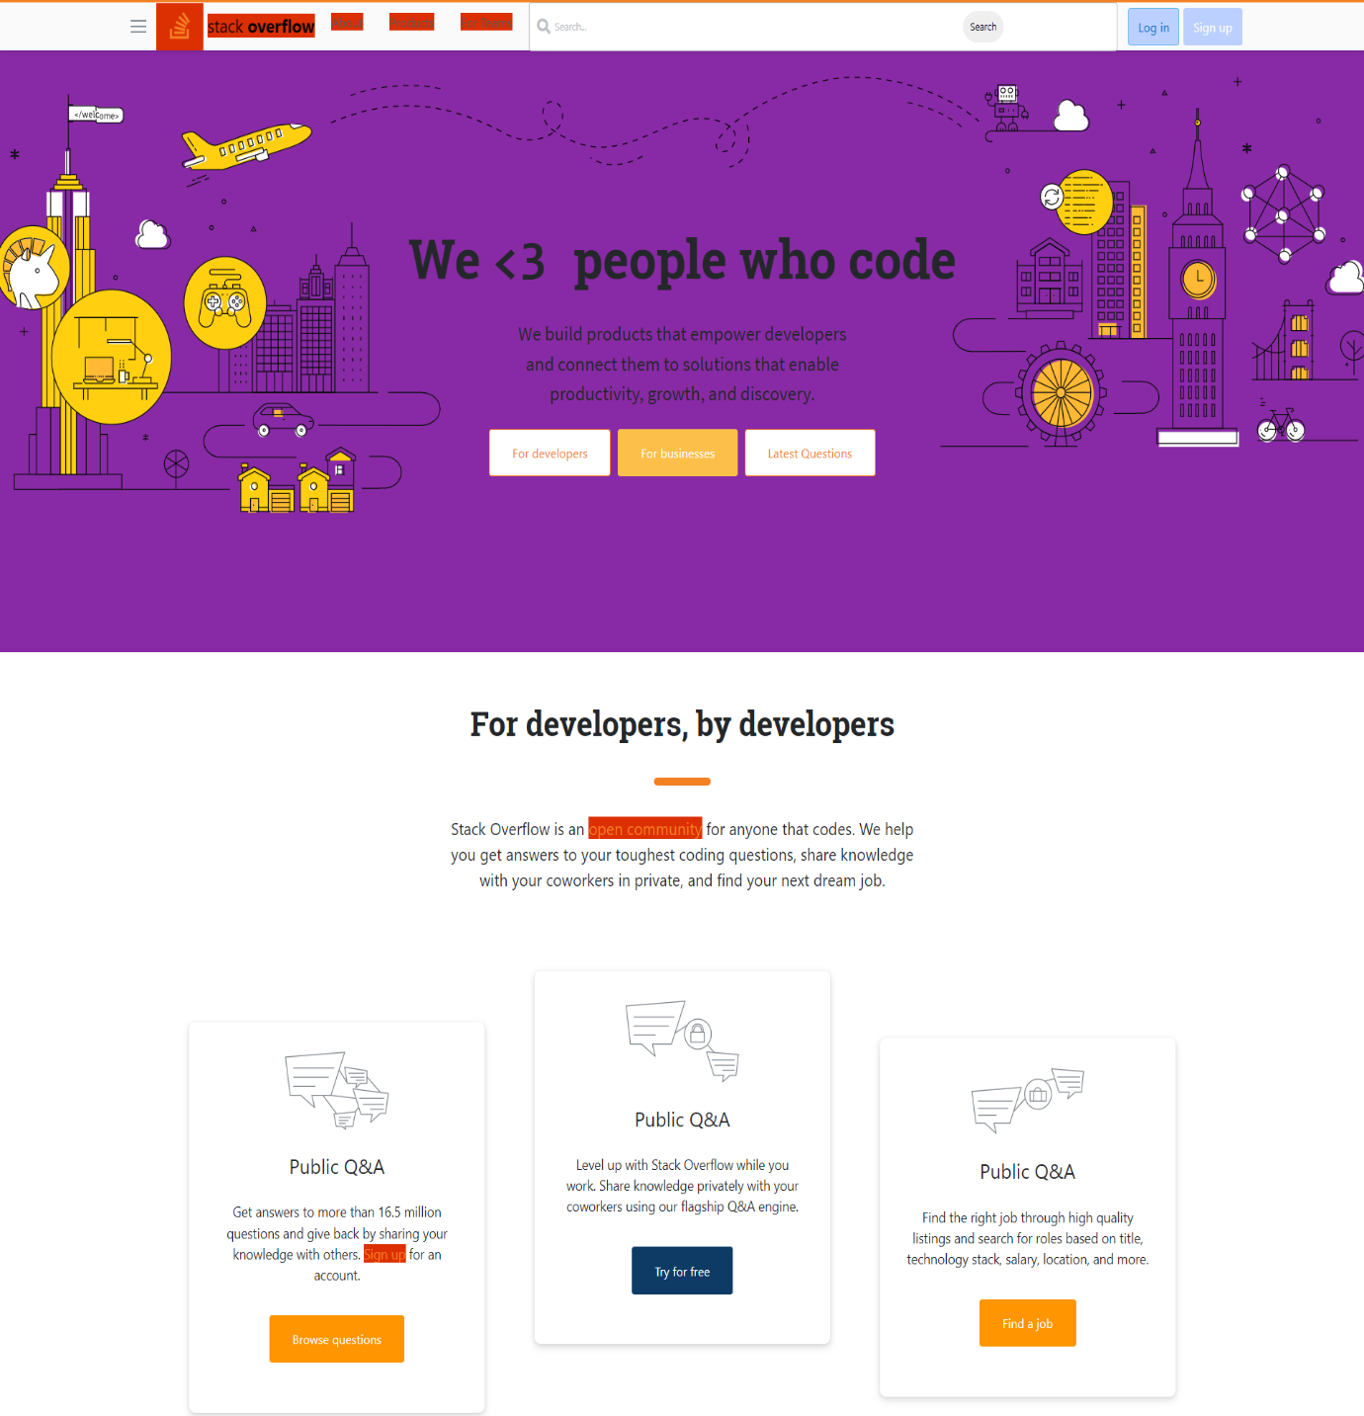

1. Home page

2. Sign-up page

3. sign-in page

4. profile page

5. update-profile page

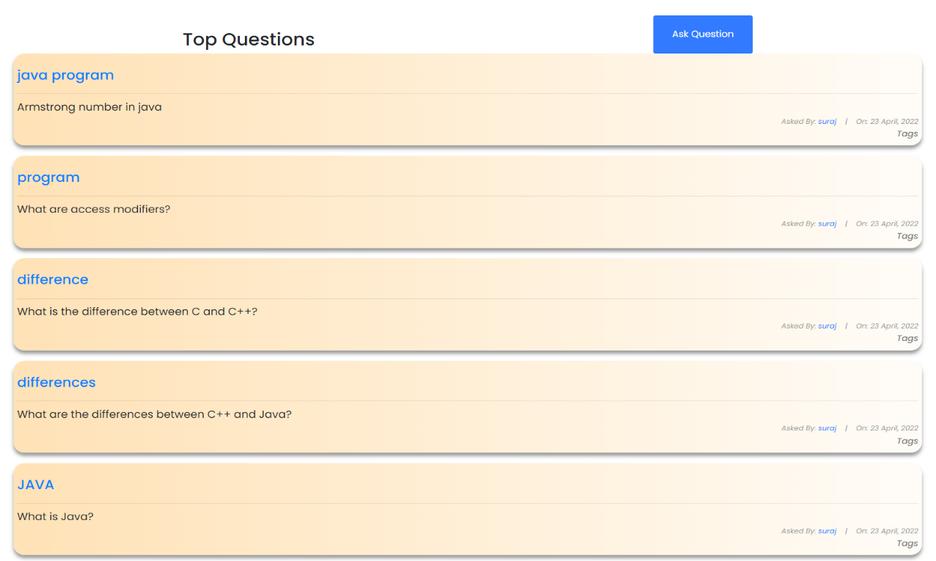

6. questions page

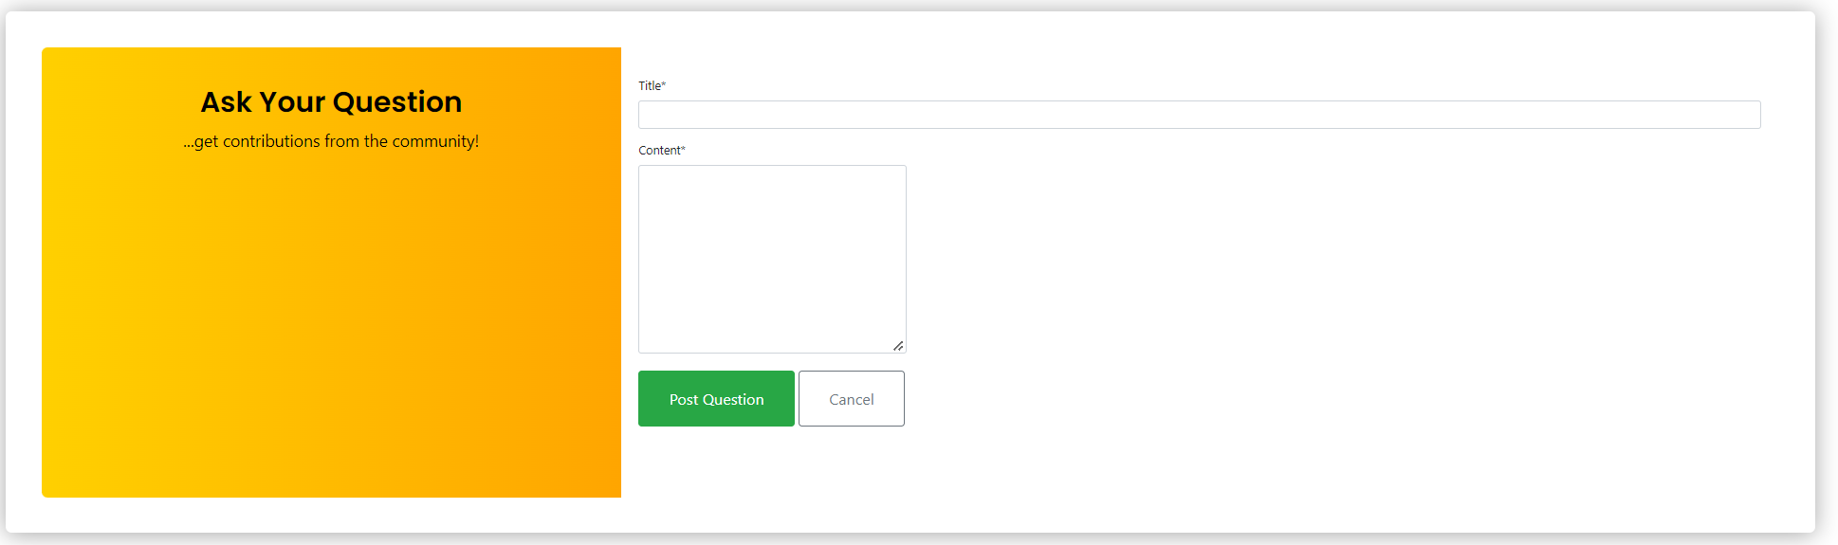

7. Ask-questions page

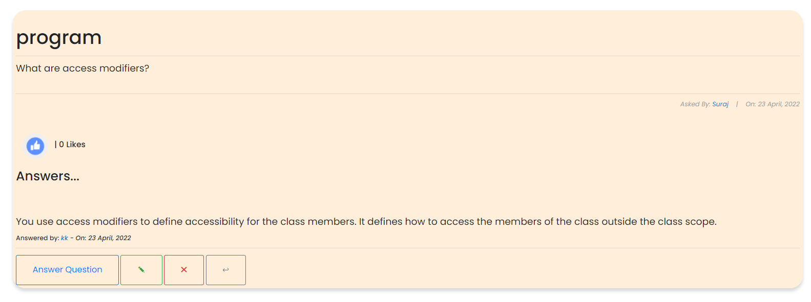

8. answer page

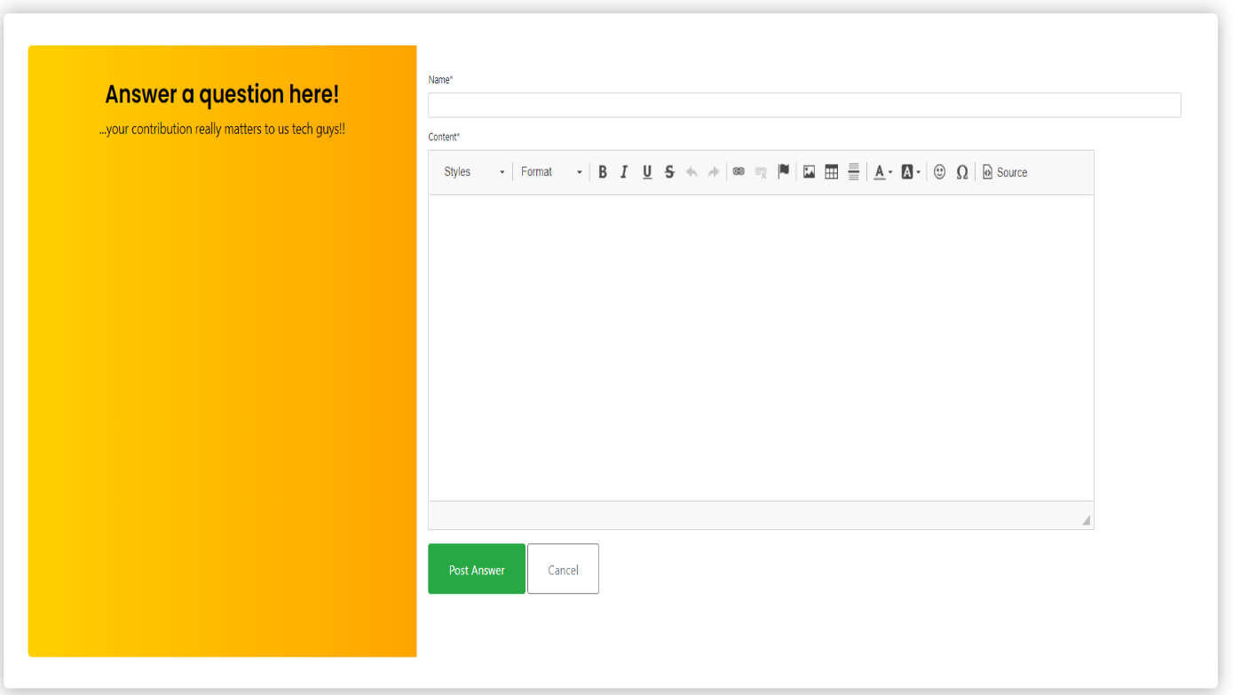

9. Write-answer page

**BIBLOGRAPHY**

* <https://javatpoint.com>
* <https://geeksforgeeks.org>
* <https://youtube.com>

**TEAM DETAILS**

This project is done by

* Suraj B Prakash (1DT19CS160)
* Sourav Nagesh (1DT19CS160)

Suraj has worked on the Backend of the application implementing python and Django.

Sourav has worked on the frontend of the application implementing HTML and CSS